**ML in Finance Logbook**

**SID – 2333889**

**Name – Subhro Mukherjee**

**Week 1**



**Week 2**

**Week 3**

**Week 4**

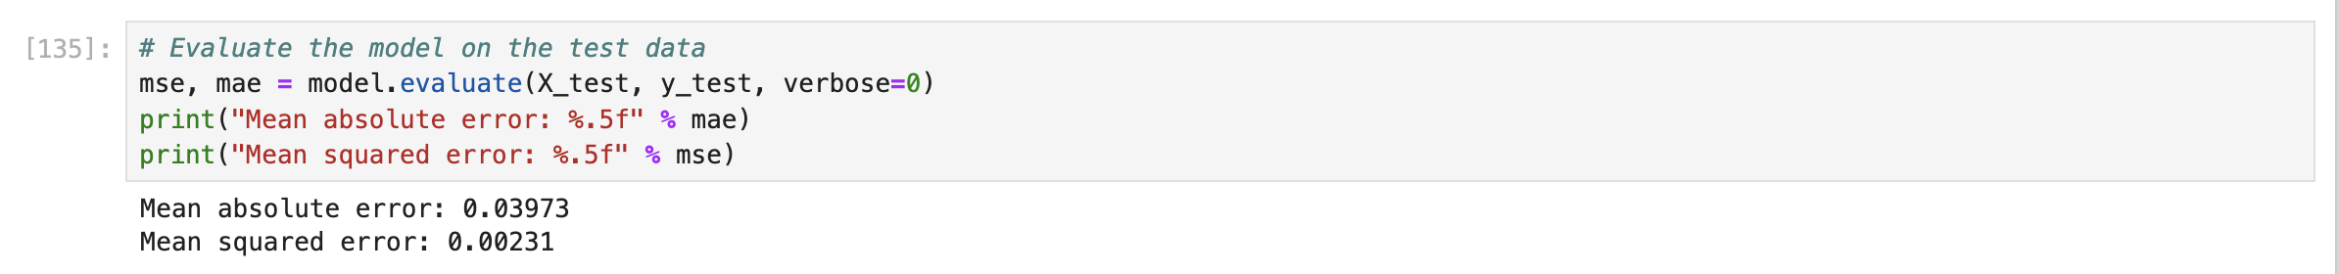

Lab mae

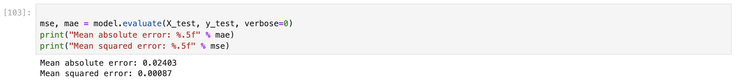

**Week 5**

Lab mae

**WEEK 6**

**WEEK 7**



